Secure DevSecOps Pipeline Implementation Using GitHub Actions

Abstract
Security has turned out to be a very significant element of modern software development with the rise of cloud, native and CI/CD practices. Conventional security testing methods are very slow and passive, and they usually find vulnerabilities after deployment.
In this project, a DevSecOps pipeline is implemented to show how automated security scanning tools can be integrated into the continuous integration workflow using GitHub Actions. The pipeline conducts static application security testing (SAST) of Python code with Bandit, container image vulnerability scanning with Trivy, and dependency monitoring with Dependabot.
The project illustrates the concept of security automation in the real world by deliberately committing vulnerable code to the repository for the pipeline to fail. Then, fixing the vulnerabilities leads to successful secure builds.

Aim of the Experiment
To design and implement a secure CI/CD pipeline that automatically scans source code and container images for vulnerabilities using GitHub Actions.

Objectives
- Implement DevSecOps automation
- Integrate static application security testing
- Scan container images for known vulnerabilities
- Enable automated dependency security alerts
- Demonstrate build failure and secure remediation
- Improve secure coding awareness

Tools and Technologies Used

Tool | Purpose
Github | Repository hosting and automation platform
Github Actions | CI/CD workflow automation
Bandit | Python static vulnerability scanner
Trivy | Docker image vulnerability scanner
Dependabot | Dependency vulnerability monitoring
Docker | Container platform
Python | Programming language

System Architecture
Workflow Architecture:
Developer Commit
↓
GitHub Repository
↓
GitHub Actions Trigger
↓
Bandit Code Scan
↓
Docker Image Build
↓
Trivy Vulnerability Scan
↓
Security Validation
↓
Build Pass or Fail

Theory Background
DevSecOps combines security measures into the DevOps life cycle. Conventional security testing is typically carried out after the development phase, thereby escalating the risk and the cost of the fixes. Security is shifted left in DevSecOps when vulnerabilities are found early in the development pipeline.
With SAST tools like Bandit, source code is scanned for security flaws. Container security solutions such as Trivy check the container images against the vulnerability databases. Dependency management tools such as Dependabot keep track of third, party libraries for known vulnerabilities.

Practical Implementation
- Create GitHub Repository
- Login to GitHub
- Click on New Repository
- Repository Name: “secure-devsecops-pipeline”
- Select Public Repository
- Enable README file
- Click Create Repository

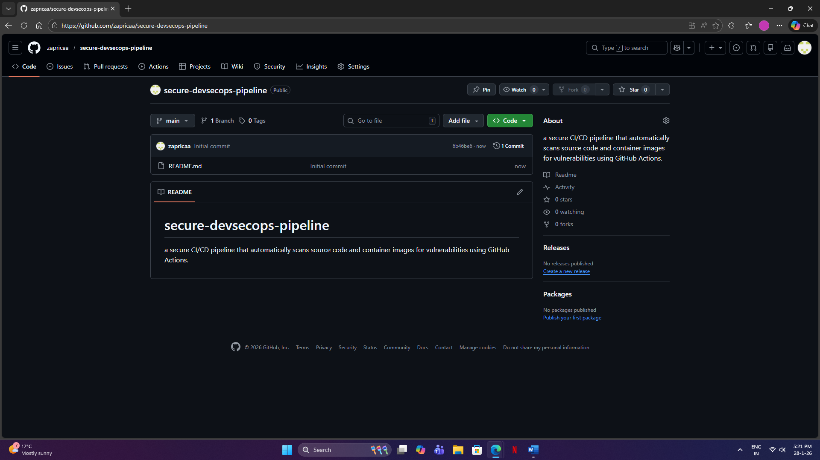

- Clone Repository on Local System
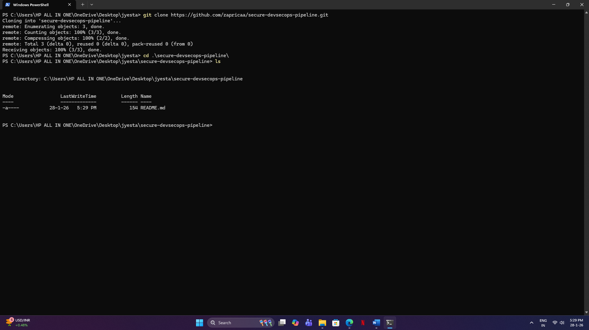

- Create Vulnerable Python Application

File Created: “app.py”
Insecure Code:
import subprocess
password = "admin123"

def run_command(cmd):
subprocess.call(cmd, shell=True)

run_command("dir")

Vulnerabilities Introduced:
- Hardcoded sensitive credentials
- Unsafe shell execution
- Command injection risk

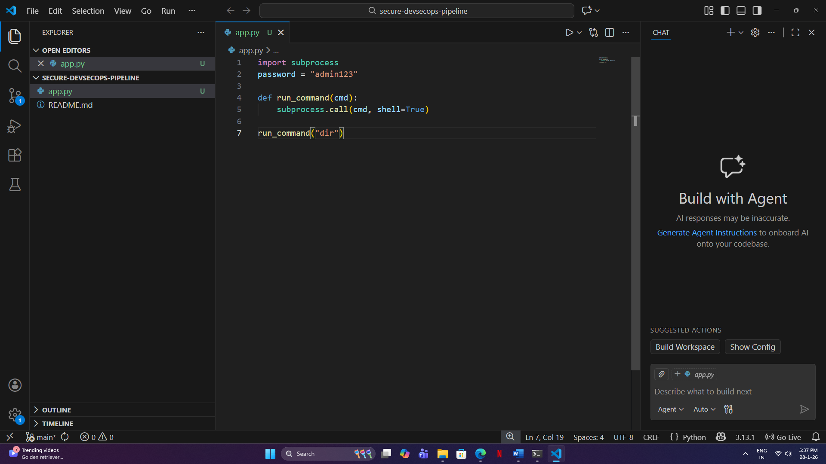

- Create Dockerfile

File Created: “Dockerfile”

Content:
FROM python:3.8

WORKDIR /app
COPY . .

CMD ["python", "app.py"]

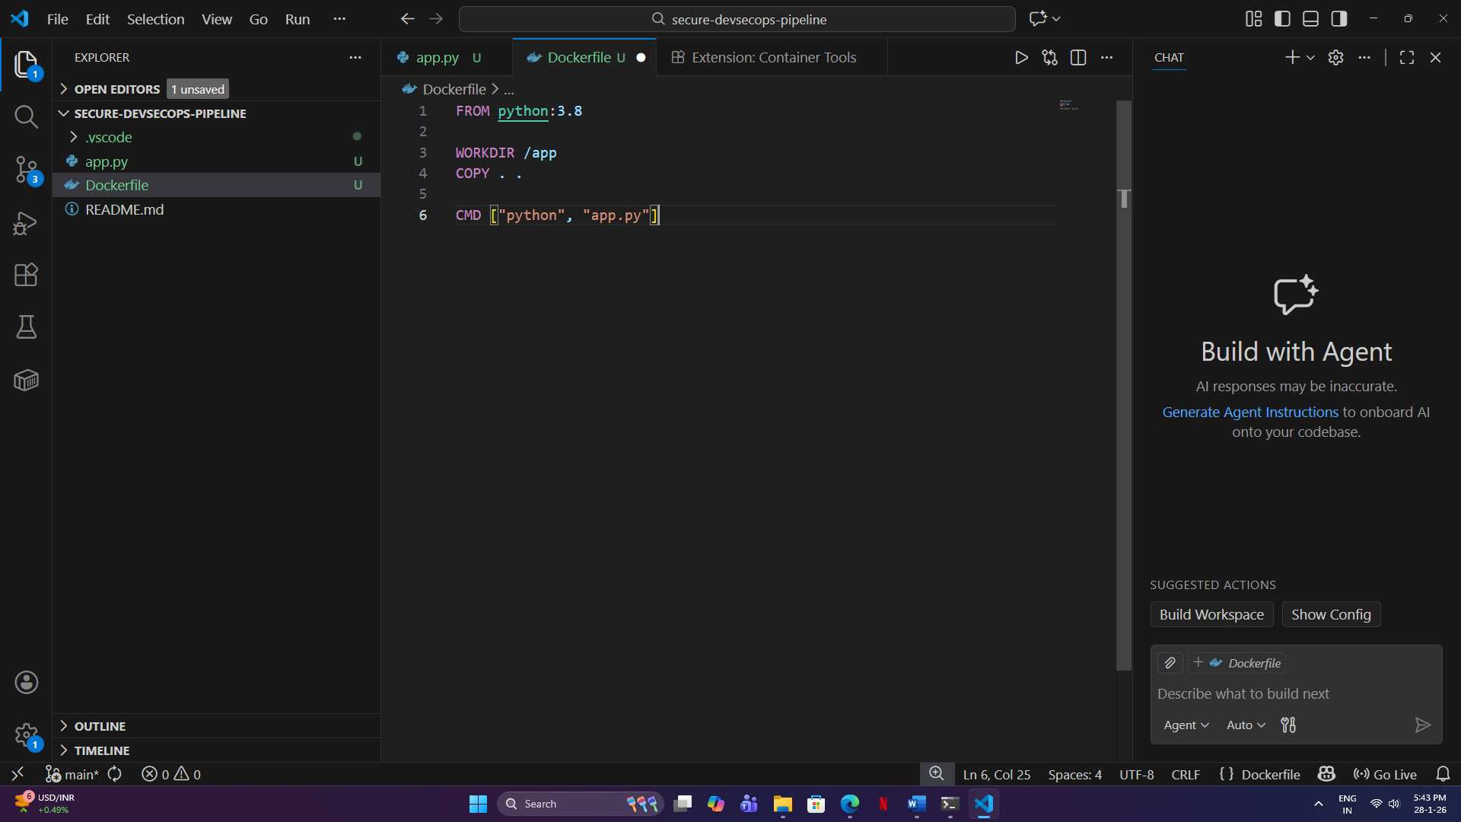

- Configure GitHub Actions Pipeline

Create Folder: “.github/workflows”
Create File: “security.yml”
Workflow Configuration:
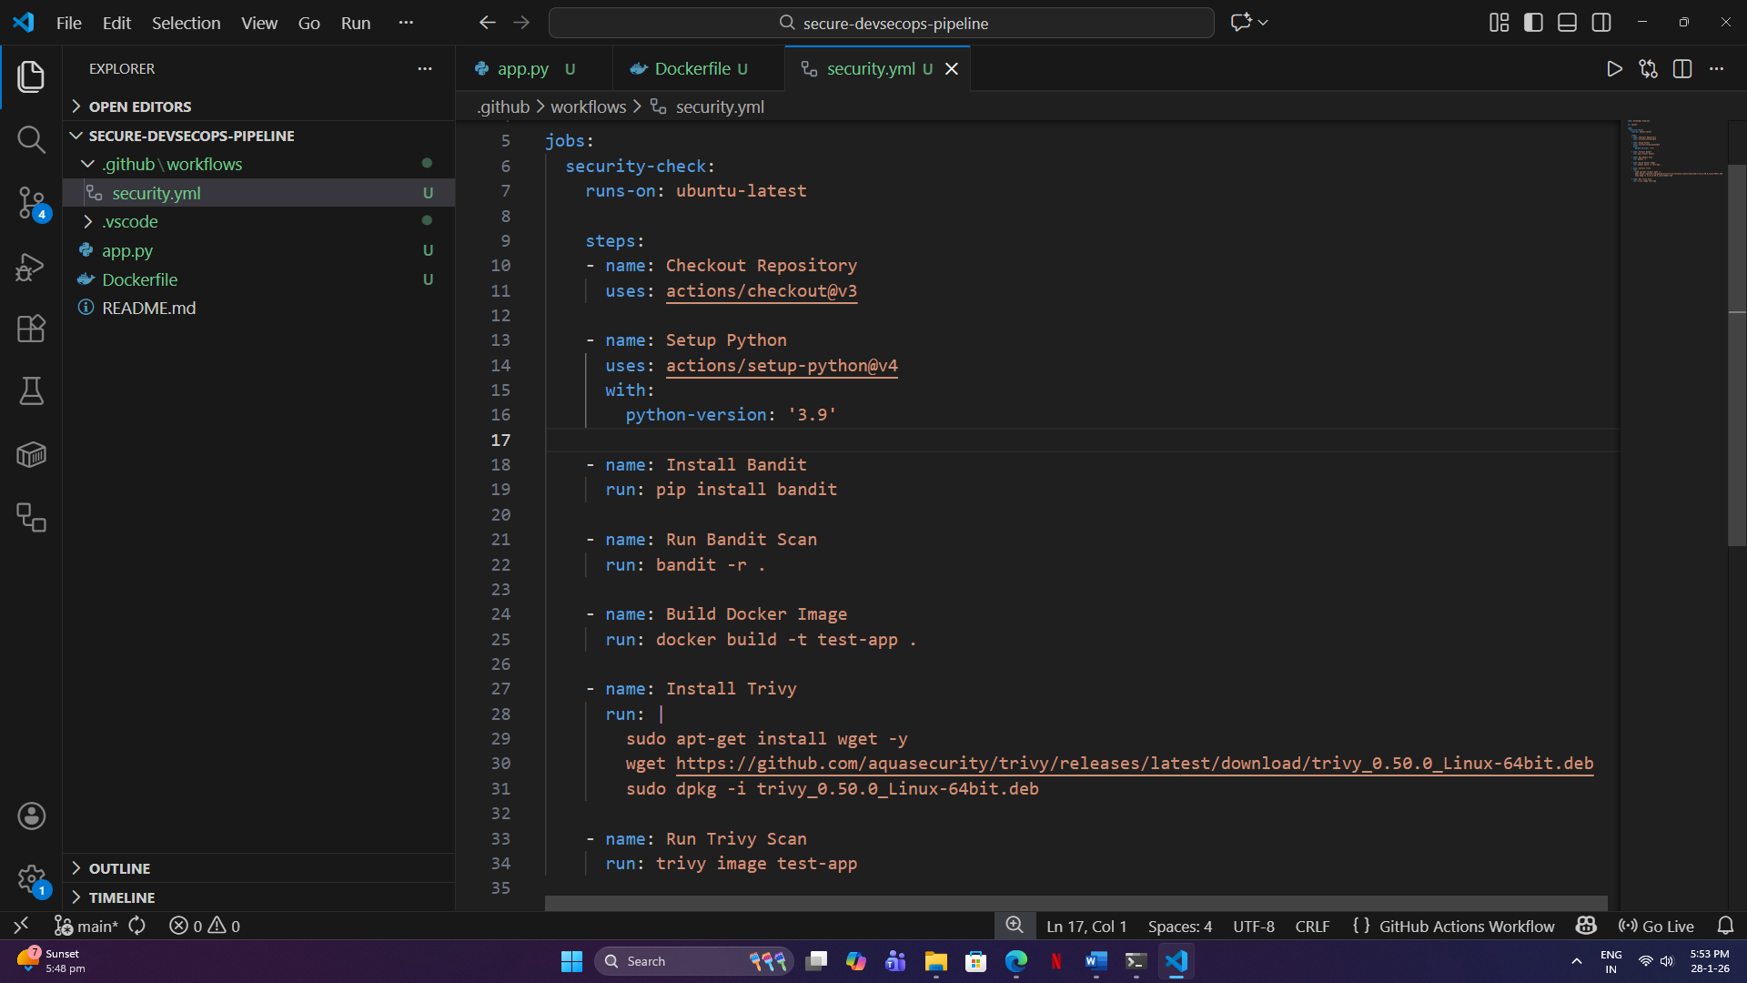

- Enable Dependabot

File Created: “.github/dependabot.yml”
Content:

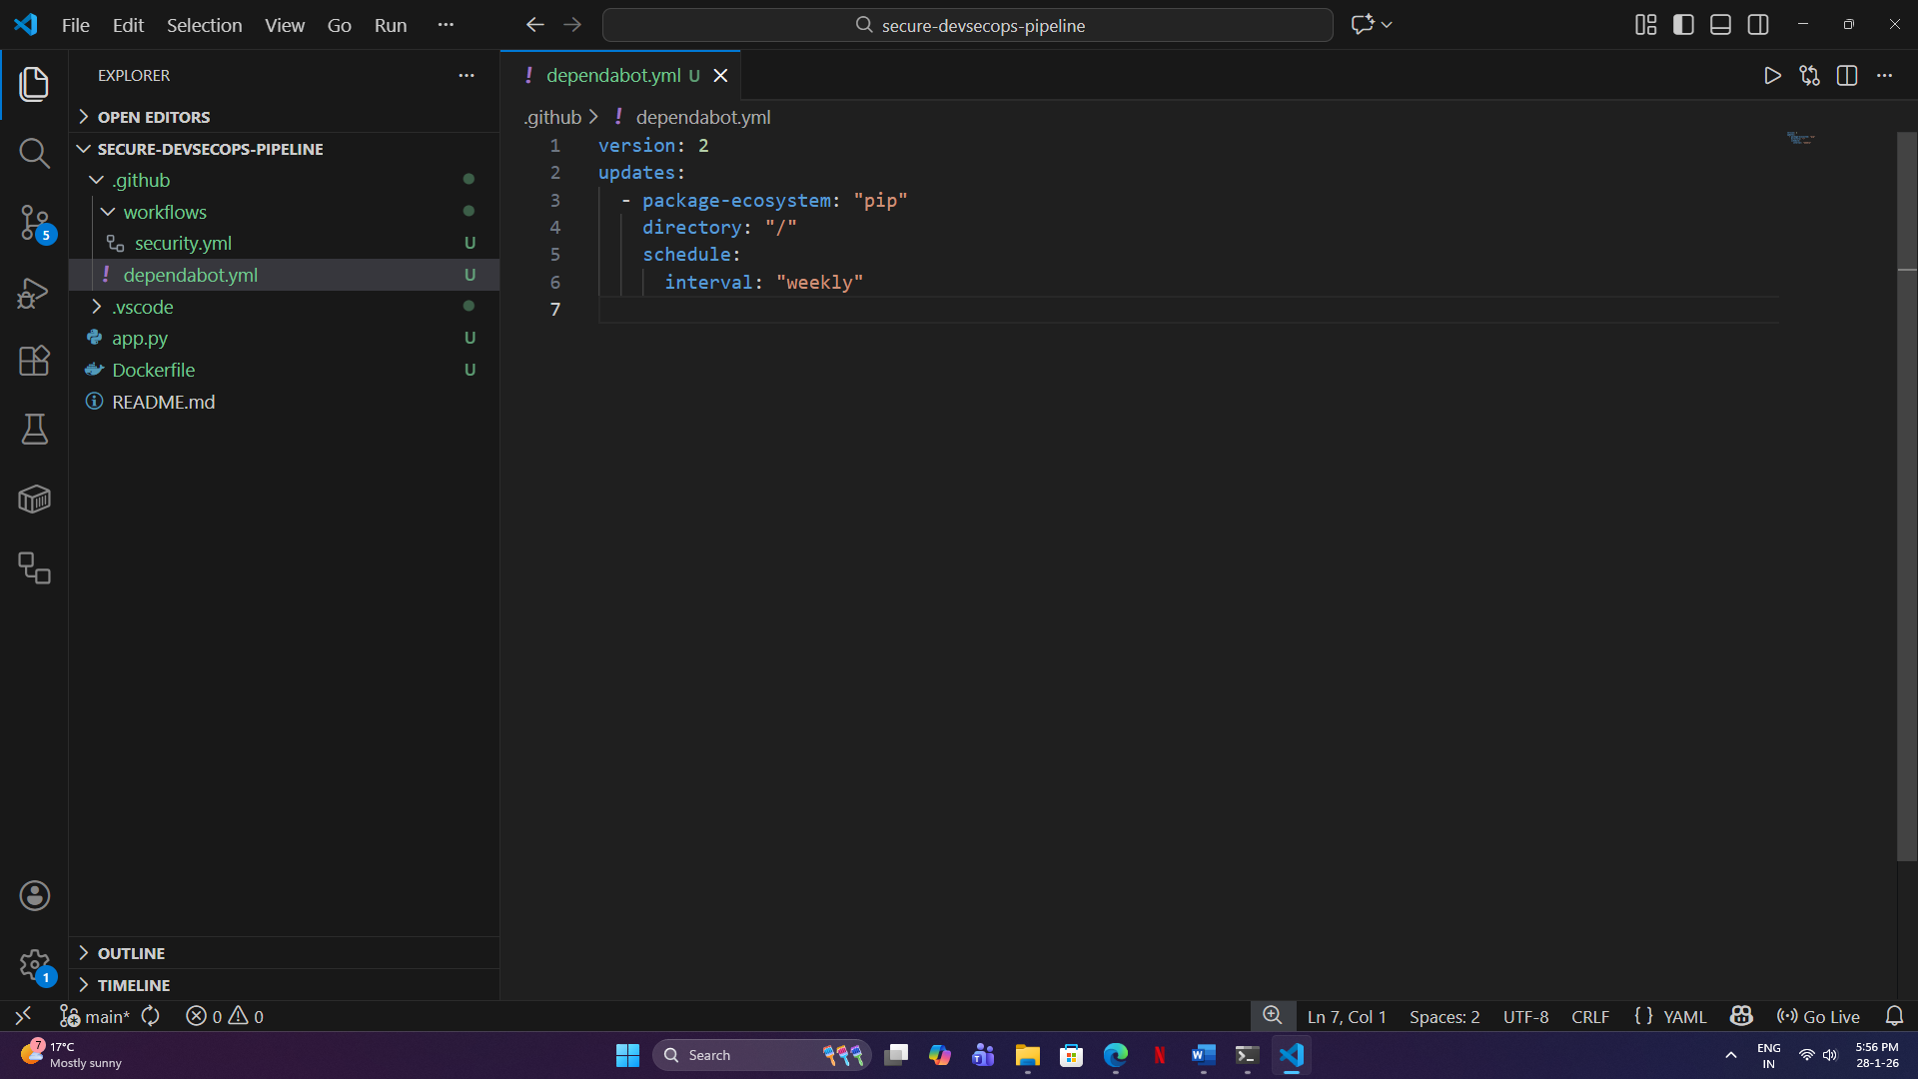

- Push Insecure Code (Failure Demonstration)

Commands:
- git add .
- git commit -m "Initial insecure implementation"
- git push

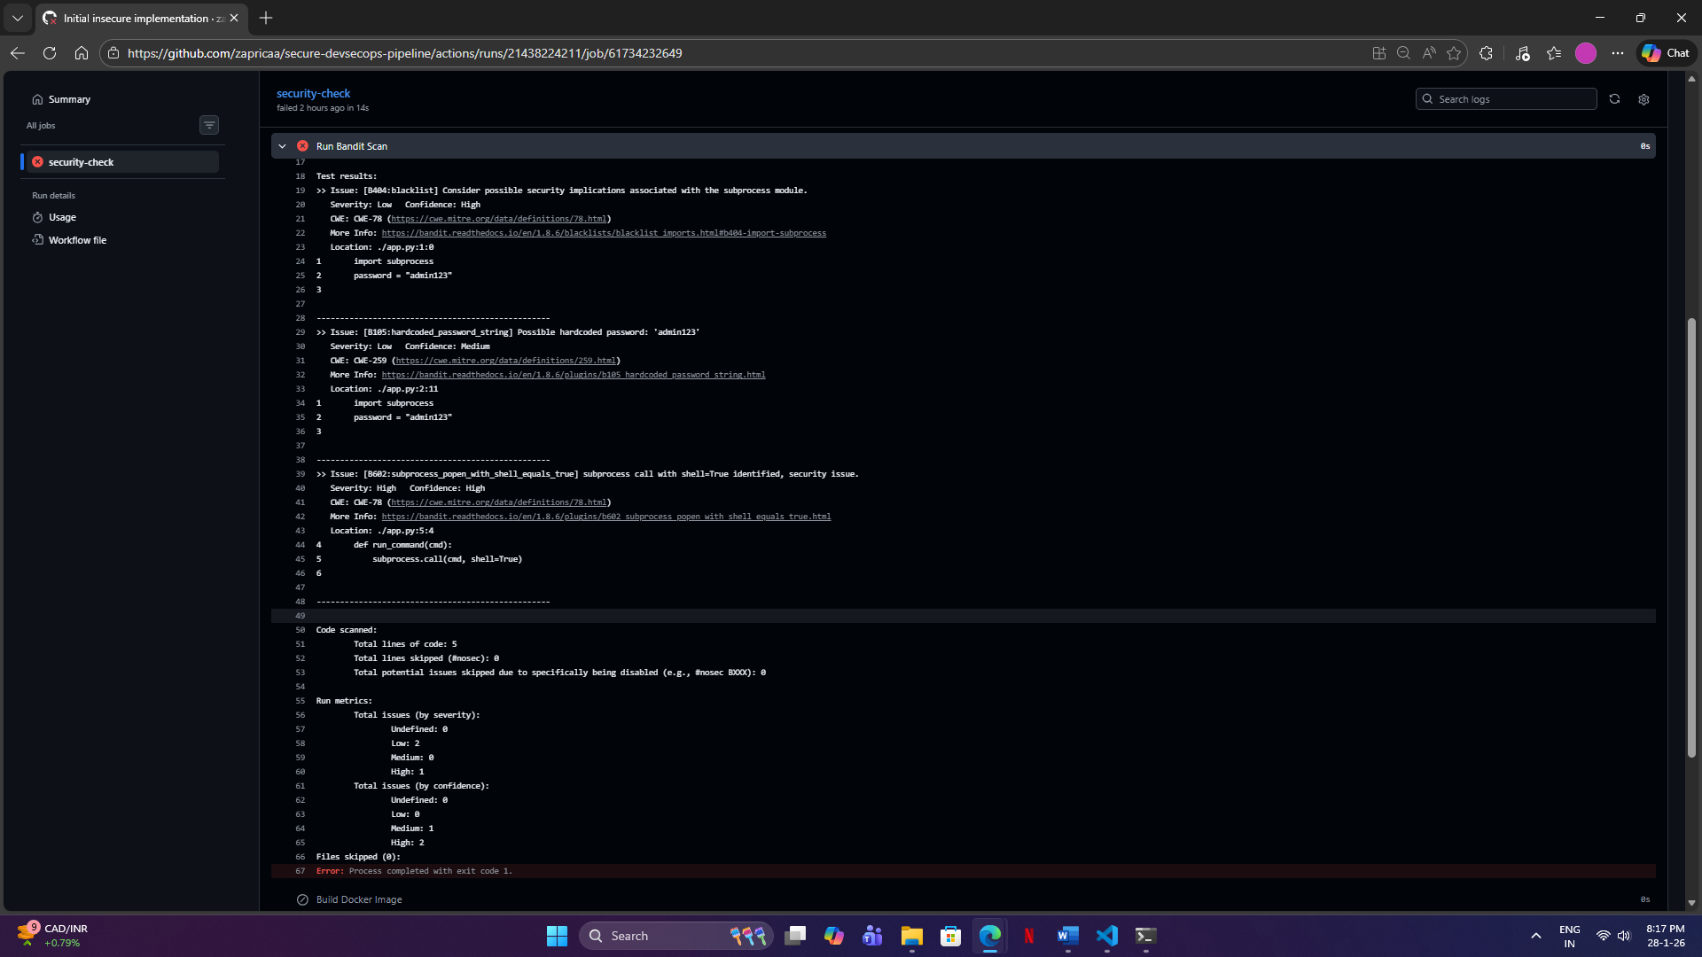

- Fix Security Vulnerabilities

Secure Python Code:
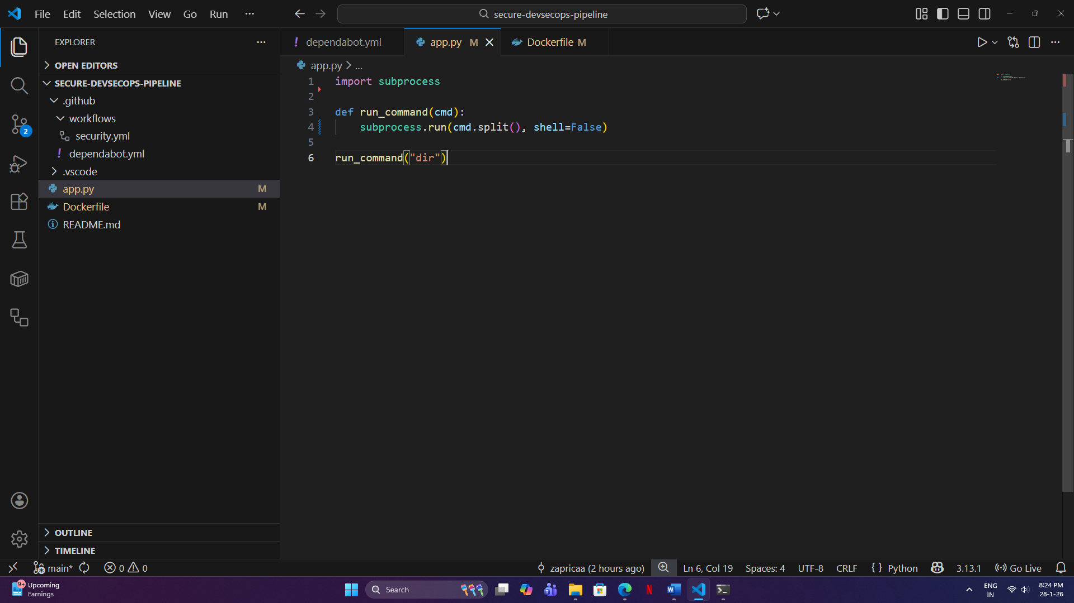

Secure Dockerfile:
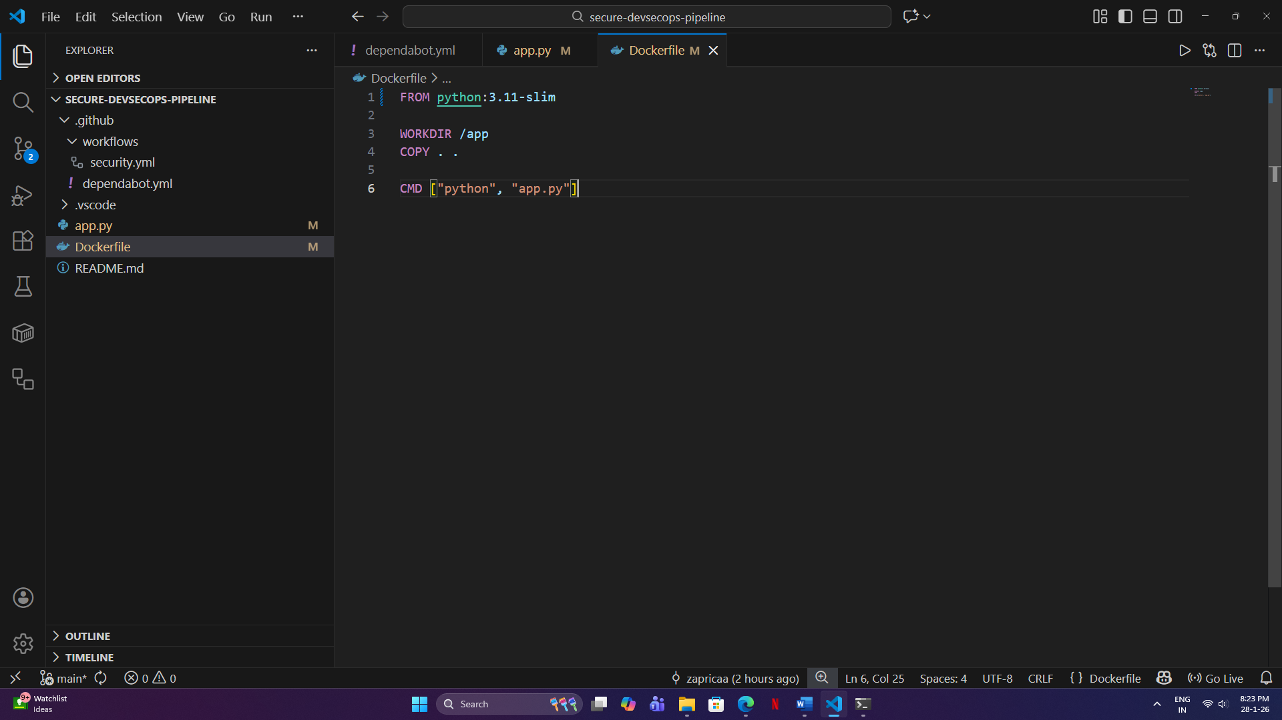

Security Improvements:
- Removed hardcoded credentials
- Prevented shell injection
- Updated base image
- Reduced container attack surface

- Push Secure Code (Success Validation)

Re-Push the code (Secure Code)

Observation:
- Bandit scan passed
- Trivy scan showed reduced vulnerabilities
- Pipeline completed successfully

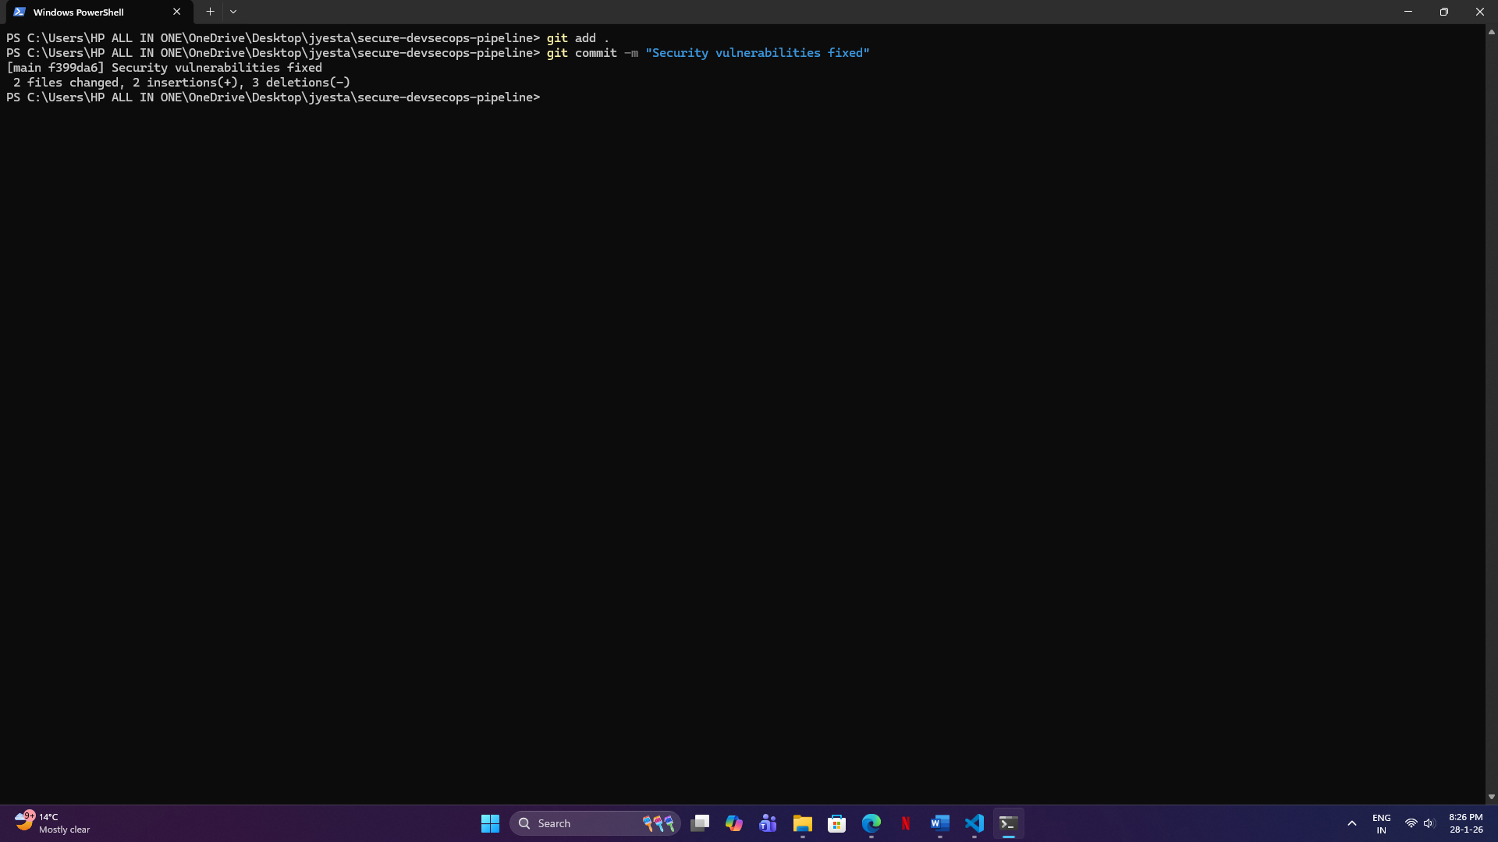
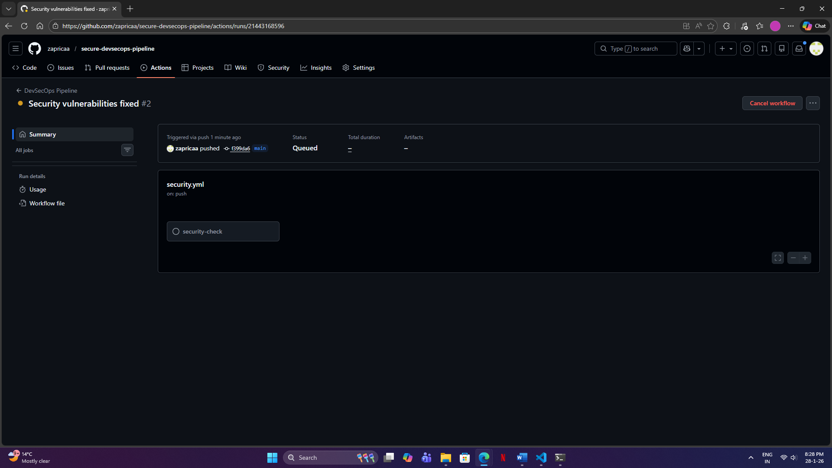

Results

Stage | Status
Insecure Code Commit | Failed
Secure Code Commit | Passed

The pipeline successfully enforced security controls.

Observations
Automated security scanning improves code quality
Early vulnerability detection reduces security risk
DevSecOps enables continuous security validation
CI/CD integration improves development efficiency

Conclusion

This project has been able to establish a secure DevSecOps pipeline integrating vulnerability scanning automation within a CI/CD workflow.
The pipeline has been able to demonstrate real, time security enforcement by disallowing insecure builds and permitting the deployment of secure codes.
This method is in line with current enterprise security practices and shows that security automation is very much essential in software development.

